 | 
🌦️ AI WEATHERWISE
AI-Powered Weather Information and Insights System
PHASE-WISE PROJECT DOCUMENT
Prepared by: Rakshitha V
Department: B.Sc. Computer Science
College: Vivekananda Vision Arts and Science College

🌦️ PROJECT OVERVIEW
AI WeatherWise is a web-based weather application that provides current weather information and a 5-day forecast for different cities. It uses the OpenWeather API to retrieve weather information and Gemini AI to generate simple weather summaries and recommendations.
The application also provides secure user registration and login, JWT authentication, and favorite-location management using MongoDB.
The project is developed using React.js, Node.js, Express.js, MongoDB, OpenWeather API, and Gemini AI.

📋 PHASE 1 – PROJECT INTRODUCTION & REQUIREMENTS
📋 1.1 Problem Statement
Users need simple and understandable weather information for daily activities, travel, college, work, and outdoor planning.
AI WeatherWise provides current weather information, forecasts, favorite locations, and AI-based weather insights in one user-friendly application.
🎯 1.2 Objectives
The main objectives are:
- To provide real-time weather information.
- To provide a 5-day weather forecast.
- To display important weather parameters clearly.
- To provide AI-generated weather insights.
- To provide secure user registration and login.
- To implement JWT authentication.
- To allow users to save favorite locations.
- To provide proper API and AI error handling.
- To create a responsive user interface.
📌 1.3 Scope
The project includes:
- City-based weather searching.
- Current weather information.
- 5-day weather forecasting.
- AI weather insights.
- User registration and login.
- Password encryption.
- JWT authentication.
- Favorite location management.
- MongoDB data storage.
- Responsive web interface.
💻 1.4 Technologies Required
Frontend
- React.js
- JavaScript
- HTML
- CSS
- Axios
- Vite
Backend
- Node.js
- Express.js
- JavaScript
- Axios
Database
- MongoDB
- Mongoose
APIs and AI
- OpenWeather API
- Google Gemini AI
Security
- JWT
- bcryptjs
- dotenv
- CORS
Development Tools
- Visual Studio Code
- MongoDB Atlas
- Thunder Client
- Node.js
- npm

🏗️ PHASE 2 – SYSTEM DESIGN & ARCHITECTURE
🏗️ 2.1 System Architecture
AI WeatherWise follows a client-server architecture.
Architecture Flow
USER
↓
REACT FRONTEND
↓
EXPRESS BACKEND
↓
┌──────────┼──────────┐
↓ ↓ ↓
MongoDB OpenWeather Gemini AI
│ │ │
└──────────┼──────────┘
↓
EXPRESS BACKEND
↓
REACT FRONTEND
↓
USER
🧩 2.2 MVC Architecture
The backend follows an MVC-style structure.
Models
- User.js
- Location.js
Controllers
- authController.js
- weatherController.js
- locationController.js
Routes
- authRoutes.js
- weatherRoutes.js
- locationRoutes.js
Middleware
- authMiddleware.js
Services
- geminiService.js
🗄️ 2.3 Database Design
User Collection
Stores:
- Name
- Email
- Password
- Role
- Created date
- Updated date
The email field is unique.
Location Collection
Stores:
- User ID
- City
- Country
- Created date
- Updated date
A unique combination of User + City + Country prevents duplicate favorite locations.
👤 2.4 User Flow
Open Website
↓
Search City
↓
Frontend sends request
↓
Backend receives request
↓
OpenWeather API provides weather
↓
Weather displayed
↓
Gemini AI generates insight
↓
5-Day Forecast displayed
↓
User Login/Register
↓
User can manage Favorites

🖥️ PHASE 3 – BACKEND DEVELOPMENT
🖥️ 3.1 Backend Setup
The backend was developed using Node.js and Express.js.
The Express server handles requests from the React frontend.
The backend runs on:
Port: 5000
🗄️ 3.2 MongoDB Integration
MongoDB is used to store:
- User information.
- Favorite locations.
Mongoose is used for database operations.
🔐 3.3 User Authentication
The authentication system provides:
- User registration.
- User login.
- Password encryption.
- JWT token generation.
- Protected routes.
- Token validation.
Passwords are encrypted using bcryptjs.
🔑 3.4 JWT Authentication
JWT is used to protect user-specific operations.
Protected operations include:
- Add favorite.
- View favorites.
- Delete favorite.
Invalid or missing tokens are rejected.
🌤️ 3.5 Weather API
The backend communicates with the OpenWeather API to retrieve current weather information.
The application displays:
- City
- Country
- Temperature
- Feels-like temperature
- Weather condition
- Humidity
- Wind speed
- Pressure
- Cloudiness
- Visibility
- Sunrise
- Sunset
📅 3.6 Forecast API
The backend retrieves forecast data and sends the required information to the frontend.
The 5-day forecast contains:
- Date
- Weather condition
- Temperature
- Humidity
- Wind speed
❤️ 3.7 Favorite Location API
Logged-in users can:
- Add a city.
- View saved cities.
- Select a favorite city.
- Remove a favorite city.
Duplicate favorite locations are prevented.
🤖 3.8 Gemini AI Integration
Gemini AI processes weather information and generates:
- Simple weather summaries.
- Useful recommendations.
If Gemini AI is unavailable or the quota is reached, the application displays a fallback message while weather information continues to work.
🔗 3.9 API Endpoints
Authentication
POST /api/auth/register
POST /api/auth/login
Weather
GET /api/weather?city=CityName
GET /api/weather/forecast?city=CityName
Favorites
POST /api/locations
GET /api/locations
DELETE /api/locations/:id

⚛️ PHASE 4 – FRONTEND DEVELOPMENT
⚛️ 4.1 React.js Setup
The frontend was developed using React.js and Vite.
Axios is used to communicate with the backend API.
🧩 4.2 Frontend Components
Navbar.jsx
Provides navigation between different sections of the application.
SearchBar.jsx
Allows users to search for a city.
WeatherCard.jsx
Displays current weather information and provides the favorite-location option.
Forecast.jsx
Displays the 5-day weather forecast.
Login.jsx
Provides the user login form.
Register.jsx
Provides the user registration form.
Favorites.jsx
Displays and manages favorite locations.
App.jsx
Controls the main application layout and weather state.
📱 4.3 User Interface
The interface contains:
- Navigation bar.
- Account Access section.
- City search.
- Current weather card.
- AI weather insight.
- 5-day forecast.
- Favorite locations.
- Login and registration.
- Footer.
📱 4.4 Responsive Design
CSS is used to make the application responsive for:
- Desktop.
- Tablet.
- Mobile screens.
⸻
🧪 PHASE 5 – API INTEGRATION & TESTING
🔐 5.1 Authentication Testing
Test | Result
User Registration | Passed
Duplicate Registration | Passed
Login | Passed
Wrong Password | Passed
JWT Authentication | Passed
Missing Token | Passed
Invalid Token | Passed
Logout | Passed
🌦️ 5.2 Weather Testing
Test | Result
Valid City Search | Passed
Empty Search | Passed
Invalid City | Passed
Current Weather | Passed
Weather Details | Passed
5-Day Forecast | Passed
❤️ 5.3 Favorites Testing
Test | Result
Add Favorite | Passed
Duplicate Prevention | Passed
View Favorites | Passed
Select Favorite | Passed
Remove Favorite | Passed
Unauthorized Access | Protected
🤖 5.4 AI Testing
Test | Result
Gemini Integration | Implemented
AI Weather Insight | Passed
AI Quota Fallback | Passed
📱 5.5 User Interface Testing
Test | Result
Navigation | Passed
Search Bar | Passed
Clear Button | Passed
Login/Register | Passed
Password Visibility | Passed
Responsive Interface | Implemented

🎬 PHASE 6 – FINAL OUTPUT & DEMONSTRATION
🖥️ 6.1 Final Application Output
The final application provides:
- 1. Home page.
- 2. Current weather information.
- 3. AI weather insight.
- 4. 5-day forecast.
- 5. User registration.
- 6. User login.
- 7. Favorite locations.
- 8. Error handling.
- 9. Responsive interface.
🎬 6.2 Demonstration Workflow
Step 1 – Start Backend
The backend is started using Node.js and Express.
MongoDB connects successfully and the server runs on port 5000.
Step 2 – Open Website
The React frontend is opened in the browser.
Step 3 – Search City
The user searches for a city such as Chennai.
The request travels:
React Frontend
↓
Express Backend
↓
OpenWeather API
↓
Express Backend
↓
React Frontend
Step 4 – Display Weather
The application displays temperature, humidity, wind speed, pressure, cloudiness, visibility, sunrise and sunset.
Step 5 – AI Insight
Gemini AI generates a simple weather summary and recommendations.
Step 6 – Forecast
The application displays the 5-day forecast.
Step 7 – Login/Register
The user can register and login securely.
Step 8 – Favorites
After login, the user can add, view, select and remove favorite locations.
Original Output Screenshots
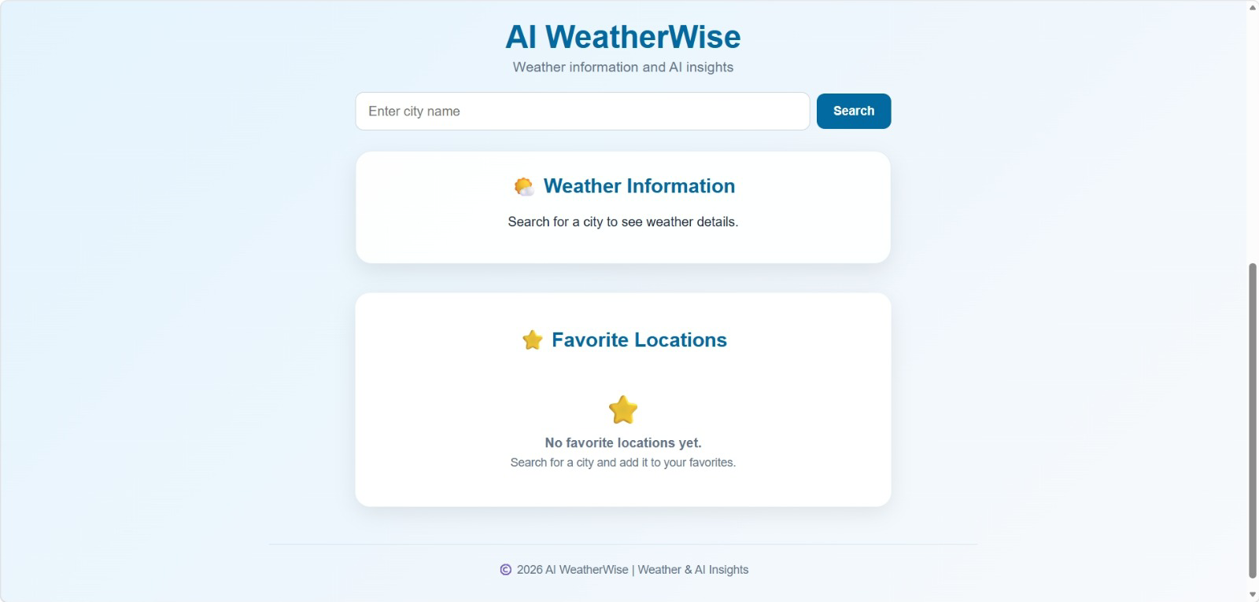

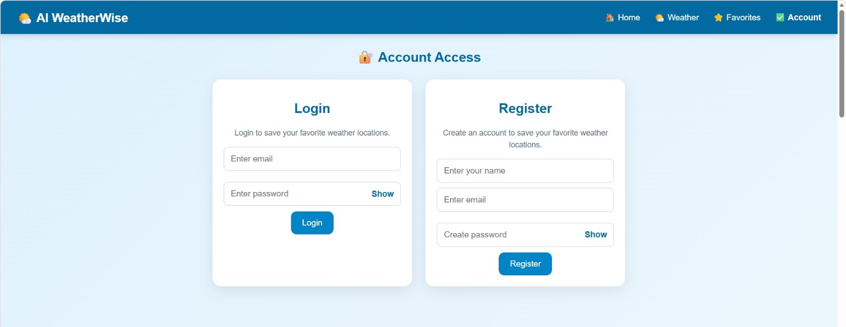

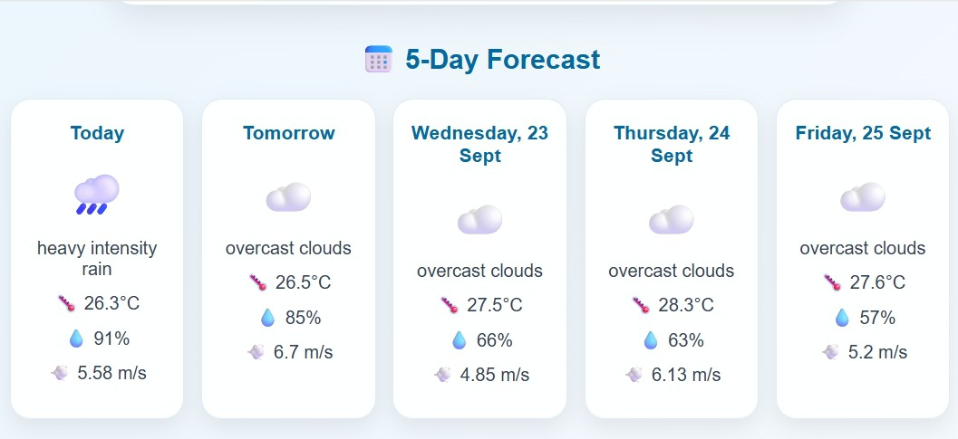

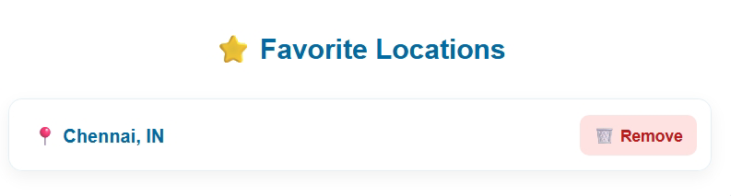

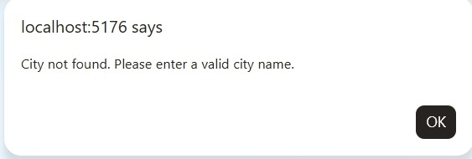

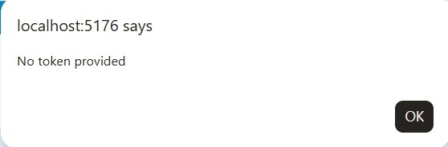

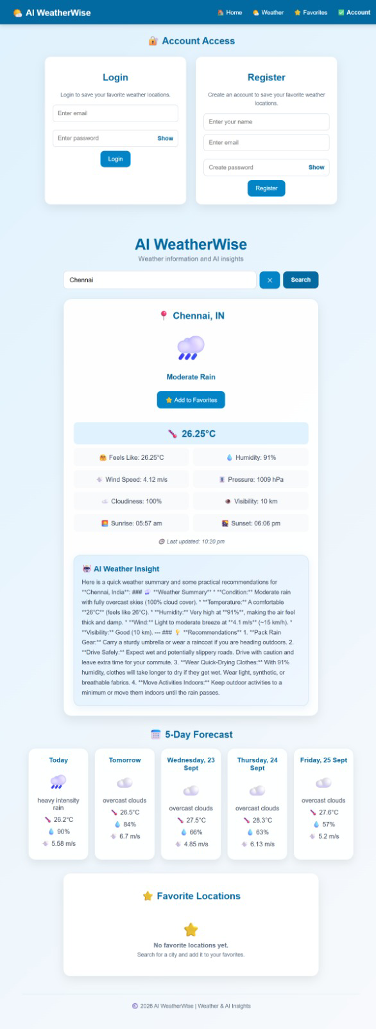

📦 PHASE 7 – FINAL SUBMISSION
📄 7.1 Final Project Report
The completed project report contains:
- Introduction
- Problem Statement
- Objectives
- Scope
- Technologies
- Architecture
- Modules
- Database Design
- API Endpoints
- MVC Architecture
- Error Handling
- Testing
- Advantages
- Limitations
- Future Enhancements
- Project Links
- Conclusion
📸 7.2 Output Screenshots
Suggested screenshots:
- 1. Home page.
- 2. Current Weather and AI Insight.
- 3. 5-Day Forecast.
- 4. Login and Registration.
- 5. Favorite Locations.
- 6. Invalid City Error.
- 7. JWT / No Token Error.
- 8. Thunder Client Current Weather.
- 9. Thunder Client Forecast.
🎥 7.3 API Testing Video
API Testing Video:
https://drive.google.com/file/d/1nfJppb_s6bI47YT9XeBhvOX8sLt_vblS/view?usp=drivesdk
🎥 7.4 Demo Video
AI WeatherWise Demo Video:
https://drive.google.com/file/d/1JbZMalNjVc6sidSWCtXG1zLtmCZ0BkSE/view?usp=drivesdk
💻 7.5 Source Code
GitHub Repository:
https://github.com/rakshithavemala91-design/AI-WeatherWise.git

✅ CONCLUSION
AI WeatherWise successfully combines React.js, Node.js, Express.js, MongoDB, OpenWeather API, and Gemini AI to create a practical weather information system.
The project provides current weather information, a 5-day forecast, AI-based insights, secure authentication, and favorite location management.
The project also demonstrates REST API integration, database management, JWT authentication, password encryption, MVC architecture, error handling, API testing, and responsive web design.
This phase-wise development provides a clear progression from requirements → system design → backend → frontend → testing → demonstration → final submission.

